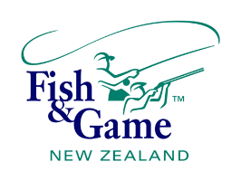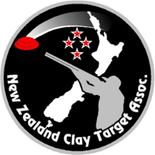

NZ FISH & GAME
SOUTH ISLAND and NEW ZEALAND SECONDARY SCHOOLS
CLAY TARGET CHAMPIONSHIPS 2024

Conducted by the Canterbury Clay Target Club, in conjunction with the NZCTA
26 – 28 September 2026
580 Chattertons Road, McLeans Island, Christchurch

Skeet
Skeet Targets (per event) $11.25
School Shooting Fee $2.50
Club Administration Fee $2.50
Skeet Island Total $16.25
Skeet National Total $16.25

DTL
Islands - 50 Targets @ 45 cents $22.50
Nationals - 65 Targets @ 45 cents $29.25
School Shooting Fee $5.00
Daily Club Administration Fee $9.00
Per Day Total Islands =$36.50
Nationals = $43.25
Total Cost, Two Days DTL $79.75

Plus Regional Teams Event $18.00 per person

Note: For DTL there will be a Junior grade (year 9 & 10) for all events. Except the Single Rise trophy (includes both boys and girls). The Seniors (year 11-13) will compete as per usual. Juniors will be eligible for HOA

All competitors must bring a signed letter from the principal of their school attesting to their eligibility to represent the school at this event. Any students without this permission will not be permitted to compete

All Schools are expected to supply personnel to referee and mark squads.

AMMUNITION: May be purchased on grounds, on presentation of a Firearms Licence.

REFRESHMENTS: Available on grounds.
PRACTICE: Friday 25th September 12.00 – 4.00 pm. One practice trap will remain open each day (Sat/Sun 10-4), unless it is required for competition.

Shoot-offs will take place at the end of each day

PROGRAMME
SATURDAY 26 SEPTEMBER 2026
Registration 8:00 am
Welcome / Opening of the N.Z.S.S. Championships
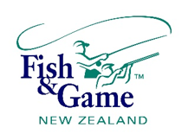
Managers and Coaches Meeting 8:00 am

EVENT 1: SOUTH ISLAND SINGLE RISE CHAMPIONSHIP and
FISH & GAME N.Z. TROPHY MATCH
Event to commence at 9 am
20 Targets off 15 metres.
Individual Trophy Match to be held in conjunction with the match.

EVENT 2: SOUTH ISLAND POINTS SCORE CHAMPIONSHIP

20 Targets off 15 metres. 4 targets per lane.
Includes the North Island Secondary Schools Points Score Teams Match.
Kilwell Teams Match: Five person open team – three person ladies team. See rules

EVENT 3: SOUTH ISLAND SINGLE BARREL CHAMPIONSHIP
10 Targets off 15 metres.

SUNDAY 27 SEPTEMBER 2026

EVENT 4: NZ SINGLE RISE CHAMPIONSHIP and
FISH & GAME N.Z. TROPHY MATCH
25 Targets off 15 metres.
Individual Trophy Match to be run in conjunction with the championship
EVENT 5: N.Z. POINTS SCORE CHAMPIONSHIP including
KILWELL TEAMS MATCH
25 Targets off 15 metres. 5 Targets per lane.
Includes the Kilwell/Gamebore N.Z. Secondary School Points Score Team Match
KILWELL TEAMS MATCH
Five person open team. All scores to count. All members to be in the same squad and attending the same school. Three persons’ ladies team.
In the event of a shoot-off, multiples of five targets per shooter to be shot.

Plus Girls Points Score Team award for the overall highest team wins a Beretta Gun for their school to use on loan as part of training at the school’s shooting club. The school has the option to purchase gun after a year at an attractive price. If the 1st place girls' team does want this, then the prize to be allocated to the next placed team who would like to receive this. The team manager/coach is to take responsibility for this firearm and must have a firearms license.

EVENT 6: N.Z. SINGLE BARREL CHAMPIONSHIP
15 Targets off 15 metres

EVENT 7: NORTH VS SOUTH LADIES TEAM MATCH
Sponsored by N.Z.C.T.A.
15 Target Points Score Competition. See rules.

EVENT 8: NORTH VS SOUTH OPEN TEAMS MATCH
Sponsored by N.Z.C.T.A.
15 Target Points Score Competition. See rules

Boys 2 Day High Gun receives a Beretta 686 SPI Sport 12ga 30: (value $3,599) each, plus fitting at Beretta NZ Auckland Showroom and coaching/shooting session (includes flight tickets for winners). Shotguns able to be upgraded with the pricing differential between models payable.
Plus

Girls 2 Day High Gun receives Beretta 686 SPI Sport 12ga 30: (value $3,599) each, plus fitting at Beretta NZ Auckland Showroom and coaching/shooting session (includes flight tickets for winners). Shotguns able to be upgraded with the pricing differential between models payable.

(winners must have a firearms licence or shotgun will be given to parent/coach with a Licence)
Conditions apply: If a competitor has previously won a gun for this event, then it shall be presented to the next highest qualifying competitor

MONDAY 28 SEPTEMBER 2026
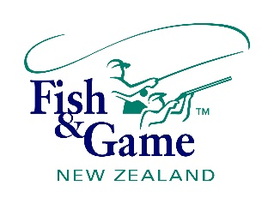
Registration from 8:30 am

EVENT 1: FISH & GAME REGIONAL TEAMS MATCH 9.00 am
30 Tgt Triples off 18m. Entry $18.00 per person

EVENT 2: SOUTH ISLAND SKEET CHAMPIONSHIP
25 Targets Skeet

All shooters eligible to compete in the National Championships

EVENT 3: NEW ZEALAND SKEET CHAMPIONSHIP
25 Targets Skeet
The national two person team events will be run in conjunction with the N.Z. Skeet event

Island Aggregate High Gun (Over all Island events, including Skeet),
SPONSORED BY TARGET PRODUCTS LTD

National Aggregate High Gun (Over all NZ events, including Skeet)
SPONSORED BY TARGET PRODUCTS LTD



